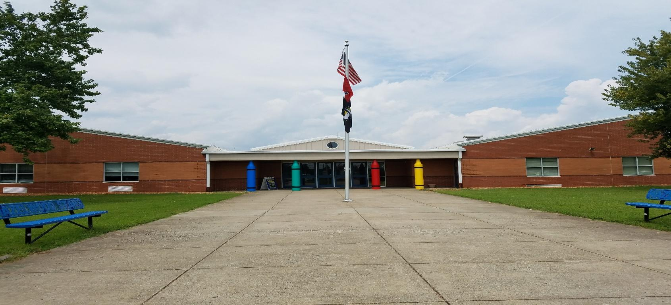

Hazelwood Elementary School

Volunteer Program
Handbook
2022-2023
Dear Hazelwood Elementary Volunteer:
We are pleased to welcome you to our Volunteer Program. Our goal is that this program will provide us with capable, caring volunteers who serve as a valuable resource to enrich our students’ school experience. The success of this program will be determined by the degree of your commitment to this program, as well the continual communication with everyone involved. The faculty, staff and administration strongly support your presence and participation in our program. We will utilize your expertise and guide you with ours.
We are committed to creating a positive training opportunity that will allow you to learn our routine as well as opportunities for performance observations and review sessions. We want to ensure you understand our daily routine, as well as emergency procedures in the event of an unforeseen occurrence.
We appreciate your willingness to give of yourself and your time. Our children will benefit from your many contributions. Your rewards will include children’s smiles, laughter and seeing our children succeed. We thank you for your support and willingness to assist us as we provide our children with 21st Century learning.

Sincerely,
Mrs. Cynthia Kerr
Principal- cynthia.kerr@cmcss.net

Volunteer Program Goals
The Hazelwood Elementary Volunteer Program has been planned and organized to benefit our students. We hope that our volunteers will help in the following ways:
- Support school, teacher, and student activities.
- Provide assistance under the direction of classroom instructors or other staff members.
- Work collaboratively with Hazelwood and the community.
- Provide feedback on the volunteer program to the coordinator.
- Provide a safe and secure environment by following and respecting school and CMCSS district procedures.

Hazelwood Rules and Procedures
- Please only use adult bathrooms. Please see the map for where they are located.
- Please stay at your designated location, not roaming or visiting other areas in the building.
- Please do not interrupt instruction.
- Volunteering includes, but not limited to the library, office, gym, PTO, Cafeteria, State testing, copies, cutting, or creating materials, events, etc..

Roles of a Volunteer
- Due to safety and security measures in place, it is imperative that you sign in and out in the front office upon each visit. A computer generated Volunteer name tag will be issued upon signing in. Please wear it in a visible location for the duration of your stay. All staff members should be able to see it when walking or working in your designated area.
- Be reliable. Contact the office if you are unable to be at school.
- Be punctual. It is very important that strict adherence to the teachers classroom schedule is followed.
- Remember that you are a role model to students. Maintain a positive attitude.
- If you have a student enrolled at Hazelwood and have a message for your child or child’s teacher, please route them through the front office so that the classroom routine is not interrupted.
- Be confidential. Do not gossip.
- Be sure to communicate with your teacher and the coordinator. Volunteers may not take students from a designated area without the consent of the teacher in charge.
- At no time is a volunteer to be left alone with a student or students without a CMCSS employee present.
- Discipline in the classroom is the teacher’s responsibility. Report discipline concerns to the teacher or admin in charge. Grading papers is also the responsibility of the teacher, as student records must remain confidential.
- Please leave your younger children at home when you are volunteering. They can be a distraction for you and the students.
- Volunteers should be positive role models. Appropriate language, appearance, and actions will be expected. Dress should be appropriate for the school setting. Caps, hats, or head coverings are not worn inside the school unless approved through the coordinator.
- Volunteering provides you time to work in the school, but it is not time to conference with your child’s teacher or other staff members.
- Smoking is prohibited on all CMCSS campuses.
- Remember, if you do not know, ask!
- Provide feedback. We want to know about your experience. Volunteering in the school will vary from teacher to teacher depending on the nature and needs of the class.

Acknowledgement

Please sign and return this form to the Volunteer Coordinator for Hazelwood Elementary School.

This form is required to begin your volunteer service.

I, __________________, acknowledge that I have read the Volunteer
(Print Name)
Handbook and understand all the expectations for Hazelwood Elementary School. Also, I have read the CMCSS Volunteer Code of Ethics and signed the CMCSS Volunteer Agreement Form.

_____________________________ _____________
Signature Date

Preferred method of being contacted:
___ Cell Phone ________________
___ Home Number ______________
___ email address __________________

Volunteer Coordinator use only below this line
Date Received: _____________

